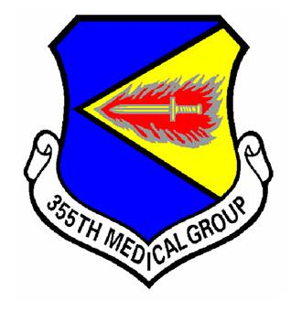
UNIT MISSION SPOTLIGHT

Unit:

355th Medical Group

Brief History:

The 355th Medical Group was established in 1955 as the 355 USAF Infirmary at the McGhee-Tyson Municipal Airport. After several designations it was activated at Davis-Monthan Air Force Base as the 355th Medical Group in 1992. The unit has 12 Campaign Streamers from Vietnam to include Phases I - IV of the Vietnam Air Offensive and the TET 69/Counteroffensive.

Slogan:

"Lightning Care...Anywhere"
355 Medical Group Patch

Mission:

Provide healthy combat forces, ready medics, and trusted healthcare to all we serve.

Vision Statement:

A premier team fueled by empowered medics delivering trusted healthcare.

Description:

The 355th Medical Group ensures combat medical readiness of the Desert Lightning Team for global contingencies. With an authorized staff of 407 and a resource allocation totaling $26 million, the Medical Group ensures that warriors at Davis-Monthan are medically fit-to-fight. In addition to training and equipping/manning 25 mobility teams, we strive to promote the health and wellness of the Davis-Monthan community by meeting the health care needs of our 54,000 eligible DoD beneficiaries. The Desert Lightening Medics also promote preventive medicine programs to maintain maximum Air Force readiness and monitor the environment and occupational work areas for hazards while supporting worldwide contingency operations.

For further MDG information including a complete list of services we offer, please visit us at:

http://www.dm.af.mil/units/355thmedicalgroup/index.asp

